Instructions
- Mark an X next to each artifact found in the Antechamber image. Not all items are in that image.
- Identify if and where each item was found in the VR tomb.
- Describe the artifact in your own words.
- For each artifact describe the purpose or role in the burial of the pharaoh and identify what we can learn about Ancient Egyptian belief in the afterlife or religion?
- At the end choose an artifact that you found interesting that you found as you were searching for the required artifacts and complete the activity for that object as well.

Artifact | Antechamber discovery image, 1922 | VR Tomb – Which room did you find it in (if any), Antechamber, Tomb Room, Treasury | Describe artifact | What was the artifacts purpose in the tomb?  What does this artifact tell us about Ancient Egyptian belief in the afterlife?
Guardian Statue(s)
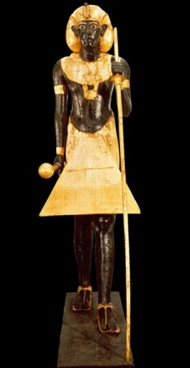
https://egyptmanchester.wordpress.com/2019/11/17/tutankhamuns-guardian-statues-symbolism-and-meaning/
Canopic chest and jars/lid
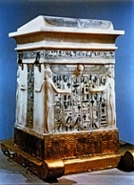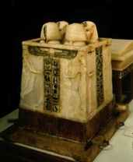

https://en.wikipedia.org/wiki/Canopic_chest

Artifact | Antechamber discovery image, 1922 | VR Tomb – Which room did you find it in (if any), Antechamber, Tomb Room, Treasury | Describe artifact | What was the artifacts purpose in the tomb?  What does this artifact tell us about Ancient Egyptian belief in the afterlife?
Ushabati
https://en.wikipedia.org/wiki/Ushabti

Chest with Panoramas
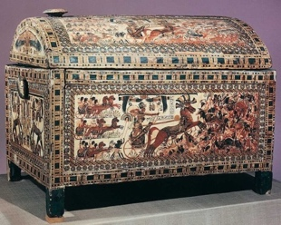
http://www.globalegyptianmuseum.org/detail.aspx?id=15097

Artifact | Antechamber discovery image, 1922 | VR Tomb – Which room did you find it in (if any), Antechamber, Tomb Room, Treasury | Describe artifact | What was the artifacts purpose in the tomb?  What does this artifact tell us about Ancient Egyptian belief in the afterlife?
Funerary couches
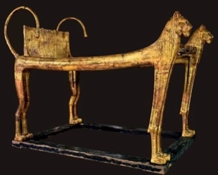
http://www.touregypt.net/museum/tutl20.htm
Cup in the form of open lotus

https://en.wikipedia.org/wiki/Lotus_chalice

Artifact | Antechamber discovery image, 1922 | VR Tomb – Which room did you find it in (if any), Antechamber, Tomb Room, Treasury | Describe artifact | What was the artifacts purpose in the tomb?  What does this artifact tell us about Ancient Egyptian belief in the afterlife?
Model boat
https://www.livescience.com/64922-lost-king-tut-boat-found.html

Chariot
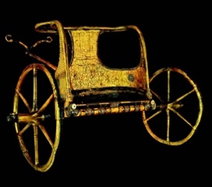
https://tutankhamunsworld101.weebly.com/golden-chariot.html

Artifact | Antechamber discovery image, 1922 | VR Tomb – Which room did you find it in (if any), Antechamber, Tomb Room, Treasury | Describe artifact | What was the artifacts purpose in the tomb?  What does this artifact tell us about Ancient Egyptian belief in the afterlife?
Choose your own artifact to examine. Draw a quick sketch here. Indicate the date of the object on the website for the blog post so it can be found.

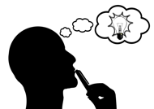Think
Compare the initial tomb image to the simulation. In what ways are they similar? In what ways are they different?
__________________________________________________________________________________________________________________________________________________________________________________________________________________________________________________________________________________________________________________________________________________________________________________________________________________________________________________________________________________________________________________________________________________________________
Why do you think certain artifacts are present in some locations (in the initial 1922 discovery image, the museum, the VR simulation), but not others? Why would the Virtual Reality designer have included or didn’t include certain artifacts in the simulation?
__________________________________________________________________________________________________________________________________________________________________________________________________________________________________________________________________________________________________________________________________________________________________________________________________________________________________________________________________________________________________________________________________________________________________
____________________________________________________________________________________________________________________________________________________________
____________________________________________________________________________________________________________________________________________________________

